

NOVAC TECHNOLOGY SOLUTIONS

User Manual

Document Version No.: 1.00

Revision History
Version No | Reason For Changes | Author | Approver
0.01 | Draft | Ravi
1.00 | Reviewed & Approved the User Manual | Ravi | NIJANTHAN PL

Table of Contents
1. Introduction 4
2. Policy Preview Before Policy schedule 4

Introduction

This user manual explains about changes incorporated in CTPL SI for Motor and Fleet products in ZIVA Philippines Module.

Changes in CTPL SI

- As per the new requirement A new “Policy Preview” button will be added before the "Policy Generate" button in the user interface .
- This will be enabled only if the proposal number is generated and installment created.

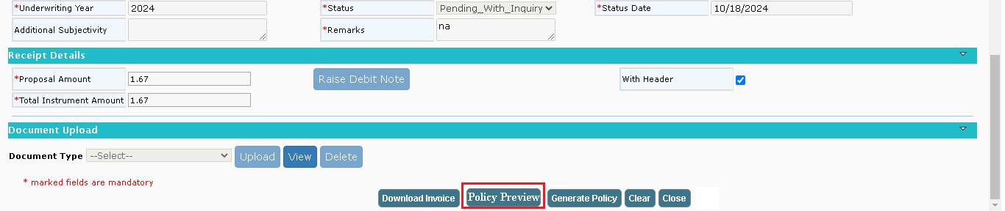
When clicking the "Policy Preview" button, the downloaded policy should include a watermark labeled “DRAFT POLICY” on all pages.

